Walkthrough 30 Debugging Tools

<https://sapui5.hana.ondemand.com/#/topic/1ff250c2038849f5991209f7e6c36f1f>



Core Changed Codes Compared to Last Version:

1 Invoices.json ProductName是正确的属性技术字段

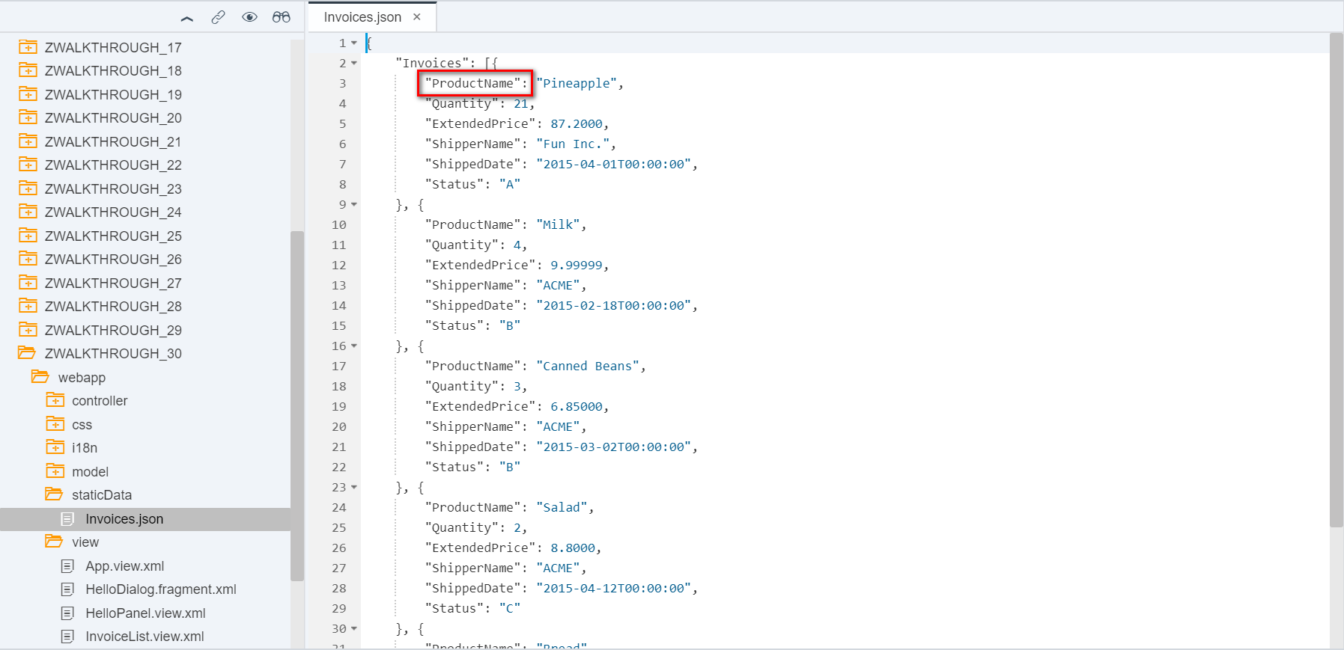

2 InvoiceList.view.xml 绑定属性拼写错误

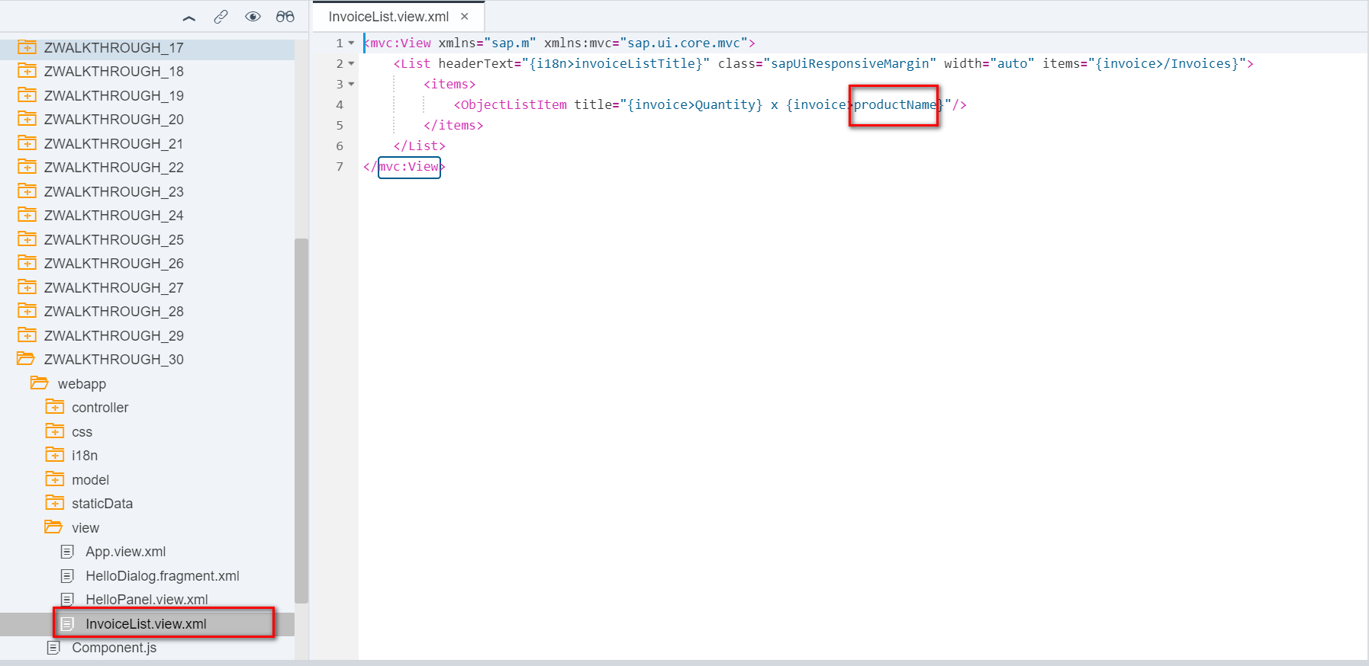

i18n 文本对象管理

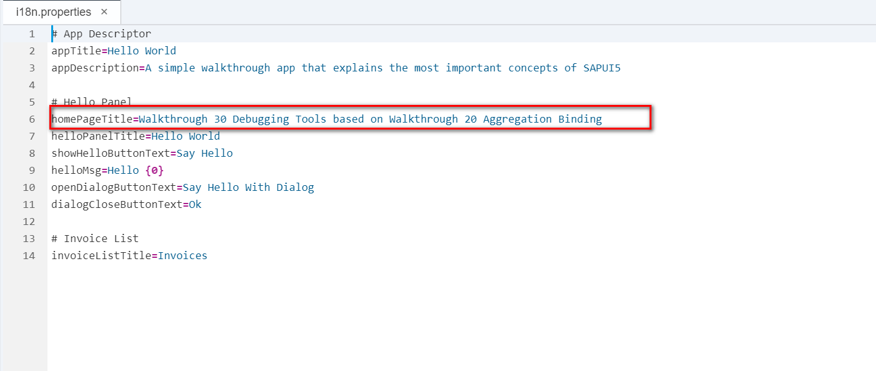

Result 缺少产品名称

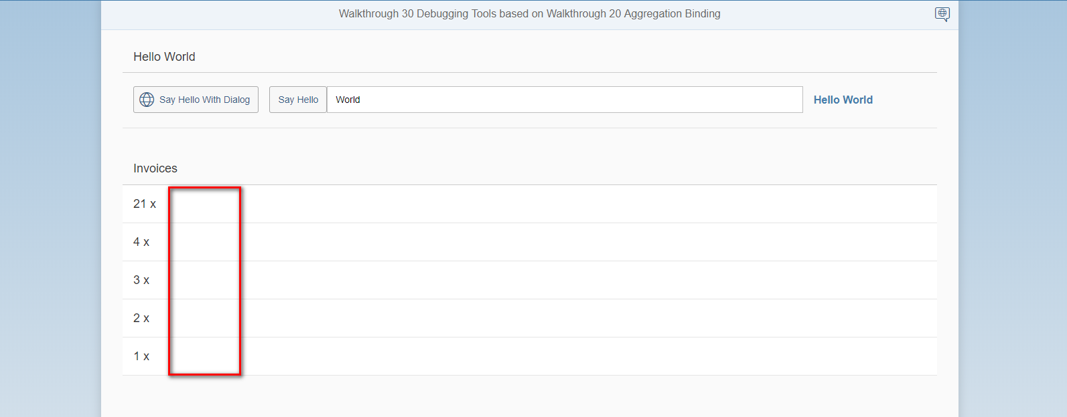

CTRL+ALT_SHIFT+S

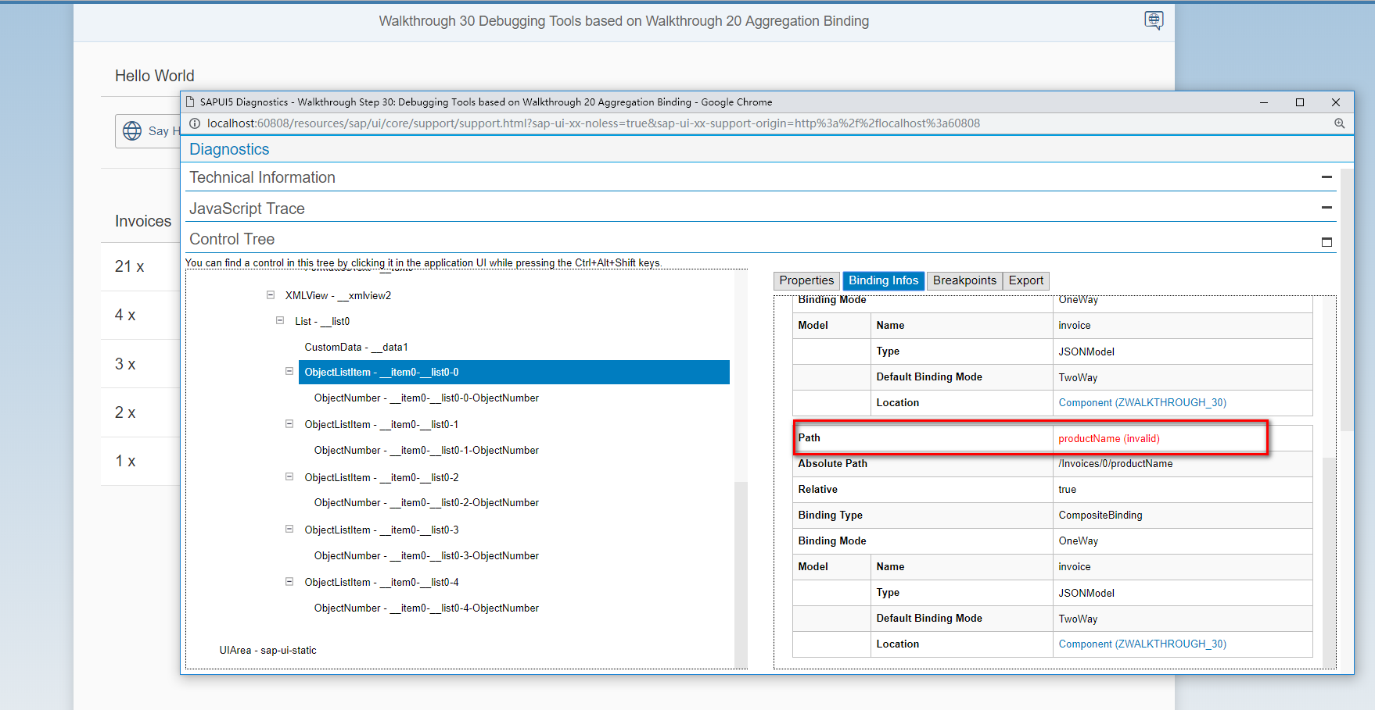

CTRL+ALT+SHIFT+P

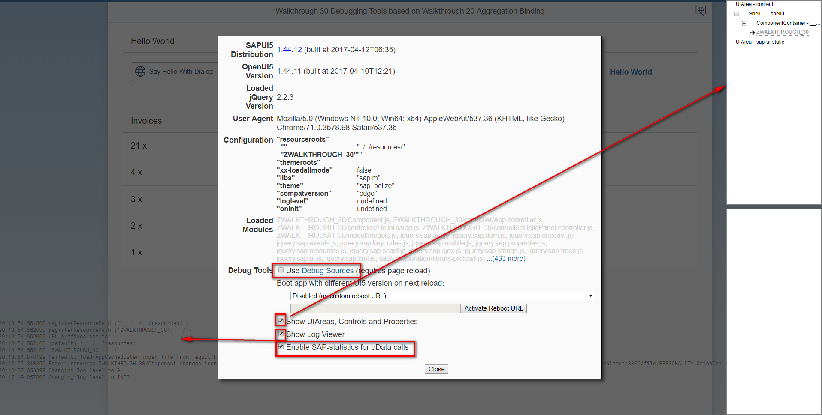

Git:

https://github.com/xiexiaop/SAPUI5-2-Round/tree/master/Projects/ZWALKTHROUGH_30

2019/02/07 XiaoMi Beijing Zac,Xie